**Lab 4: Using John the Ripper to Crack Linux Passwords**

**Introduction**

**1. To view the contents of the passwd file, type:**

**cat /etc/passwd**

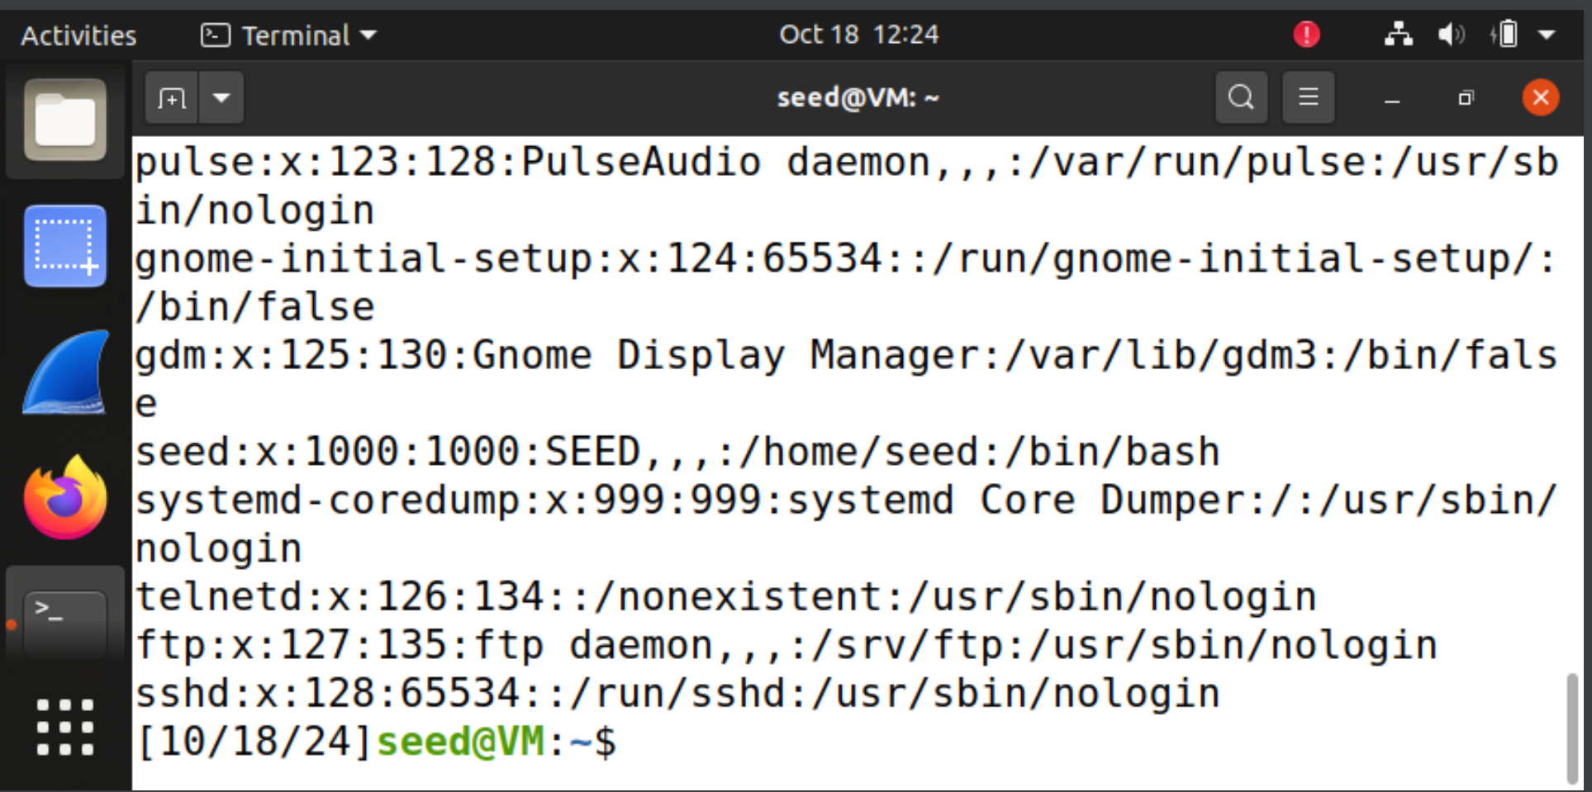

**2. View the permissions on the /etc/passwd file by typing the following command:**

**ls -l /etc/passwd**

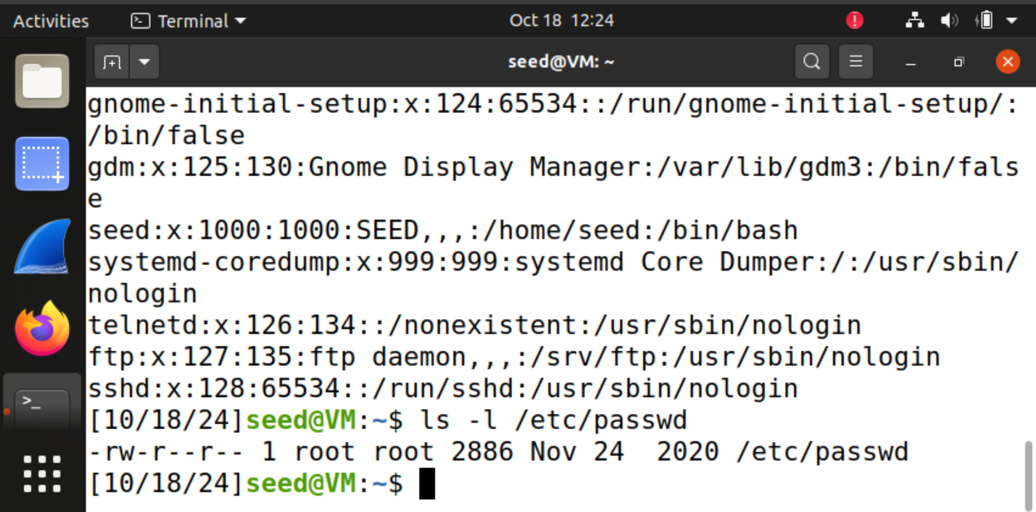

**3. To view the contents of the shadow file, type:**

**sudo cat /etc/shadow**

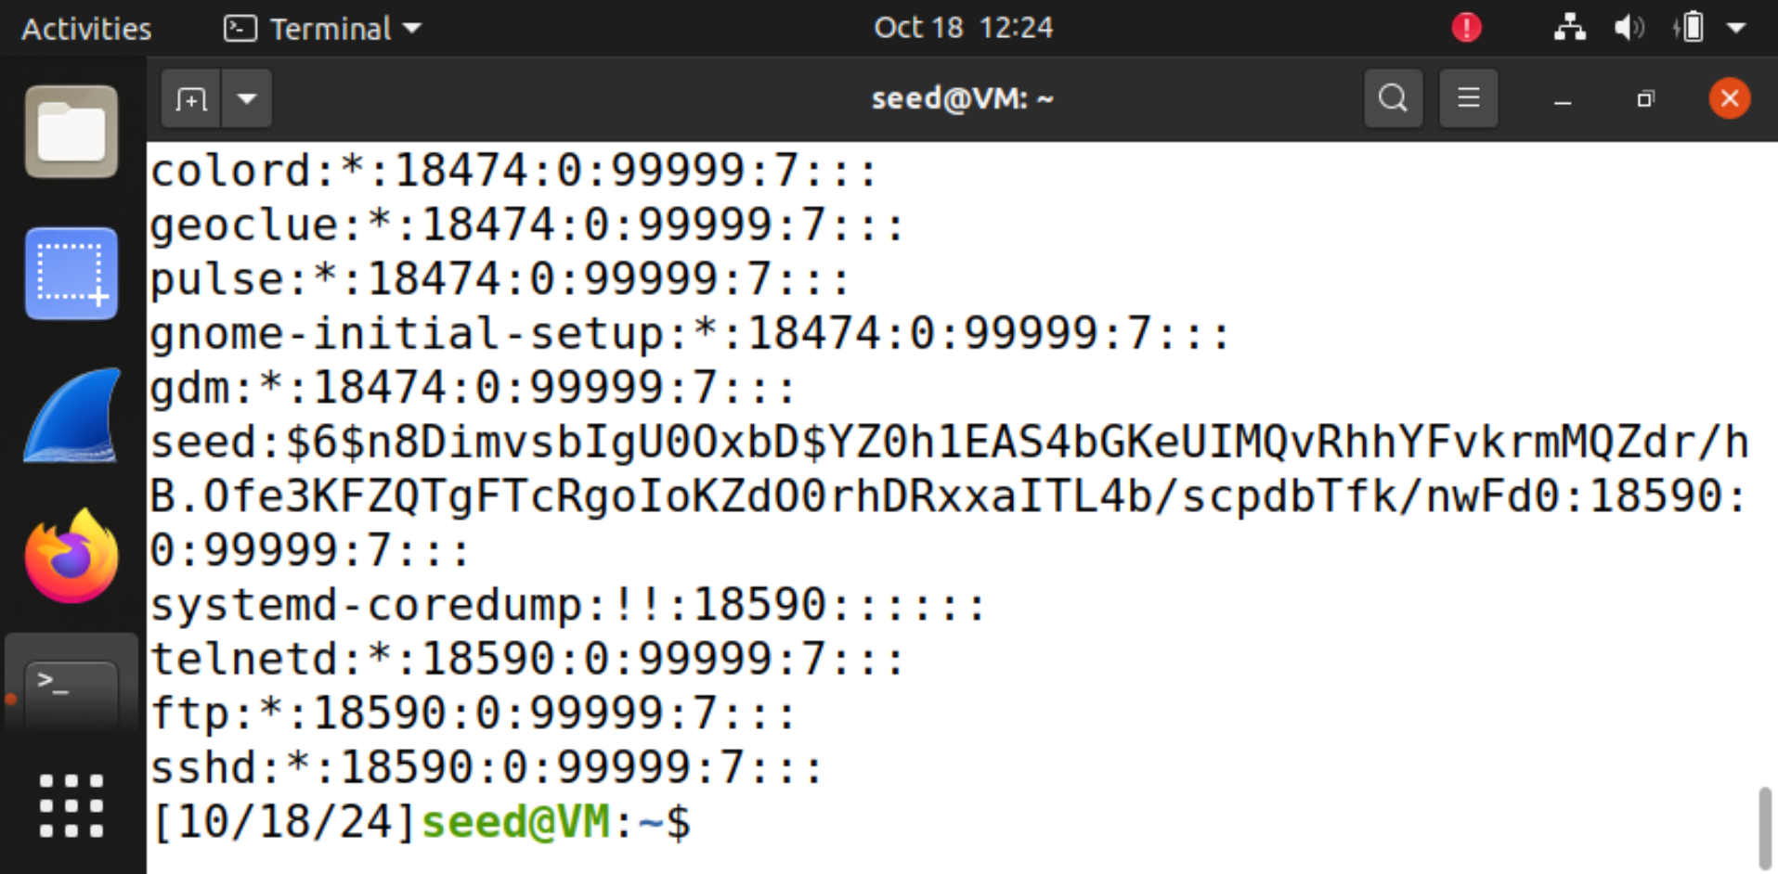

**4. To create a new user named yoda, type the following command in the terminal:**

**sudo adduser yoda (then enter password green)**

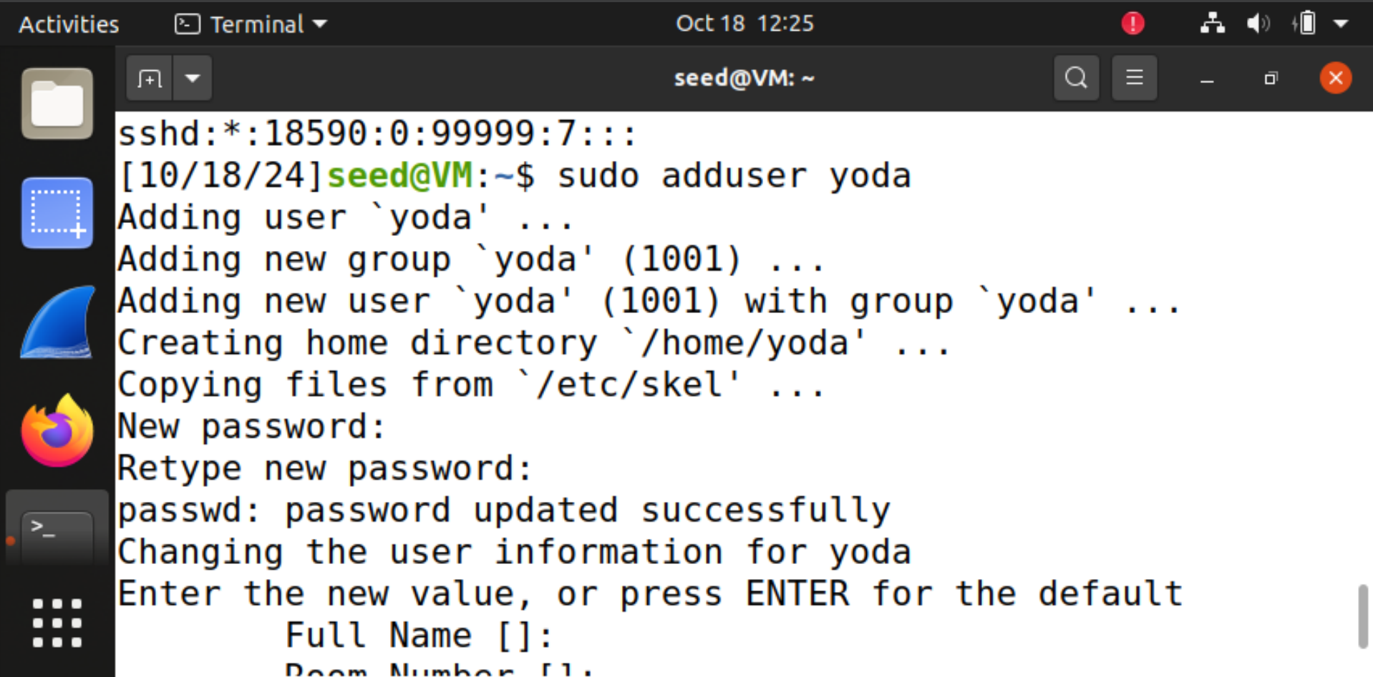

**5. To create a new user named chewbacca, type the following command in the terminal:**

**sudo adduser chewbaca (then enter password green)**

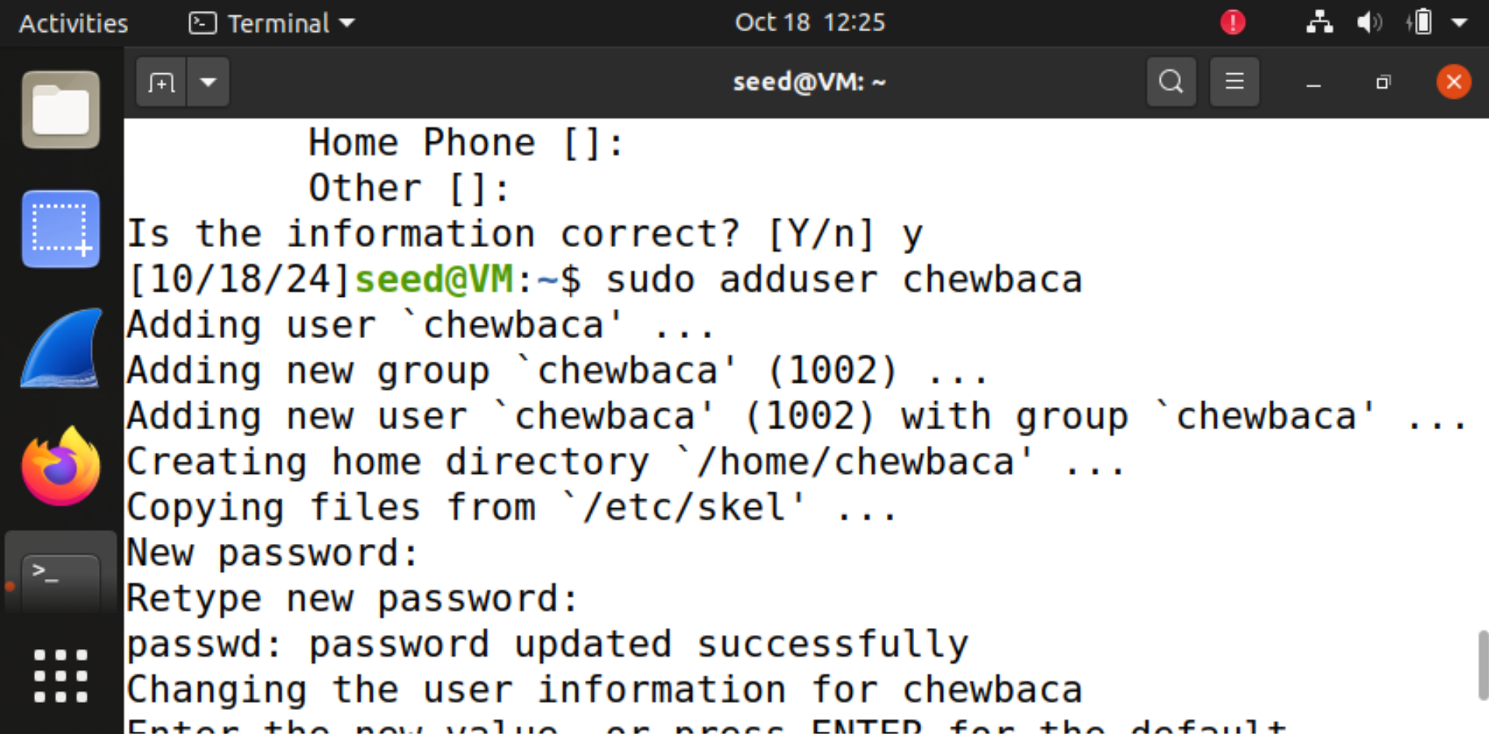

**6. Now, view the changes made to the passwd file by typing the following:**

**tail /etc/passwd**

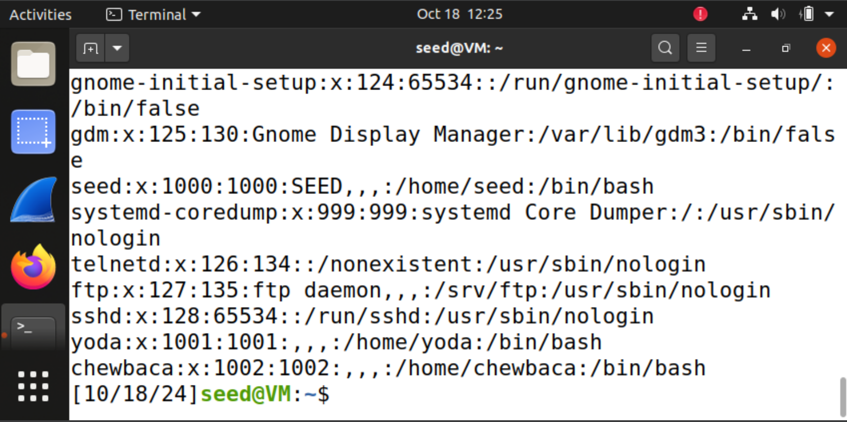

**9. Next, examine the alterations to the shadow file by typing the following:**

**tail /etc/shadow**

**The “!” symbol represents that fact the password has not been set.**

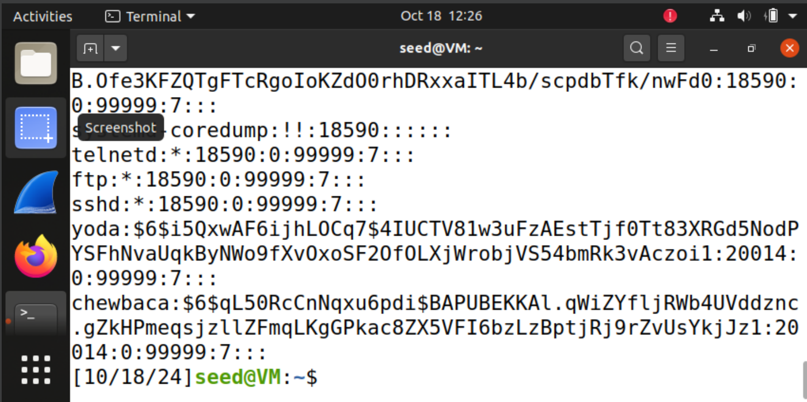

**10. Examine the entries in the auth.log related to account changes by typing:**

**tail /var/log/auth.log**

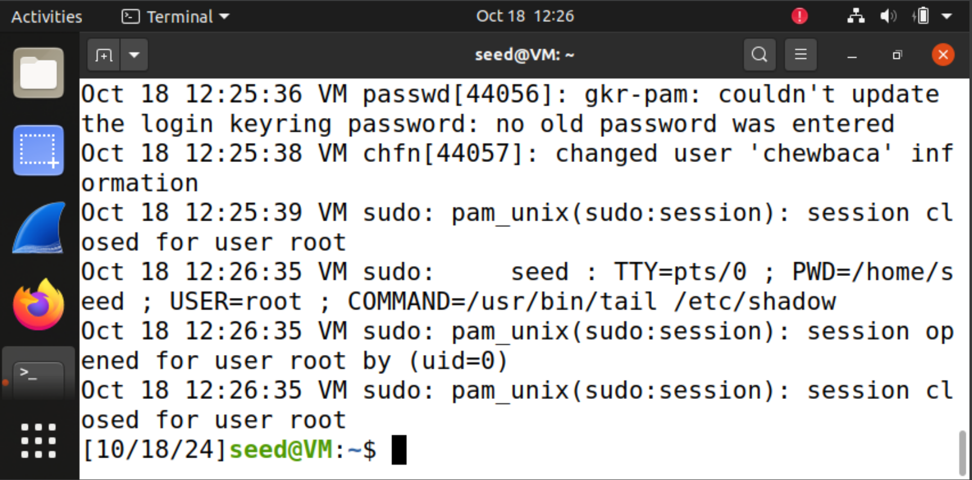

**11. Next, examine the alterations to the shadow file by typing the following:**

**tail –n 2 /etc/shadow**

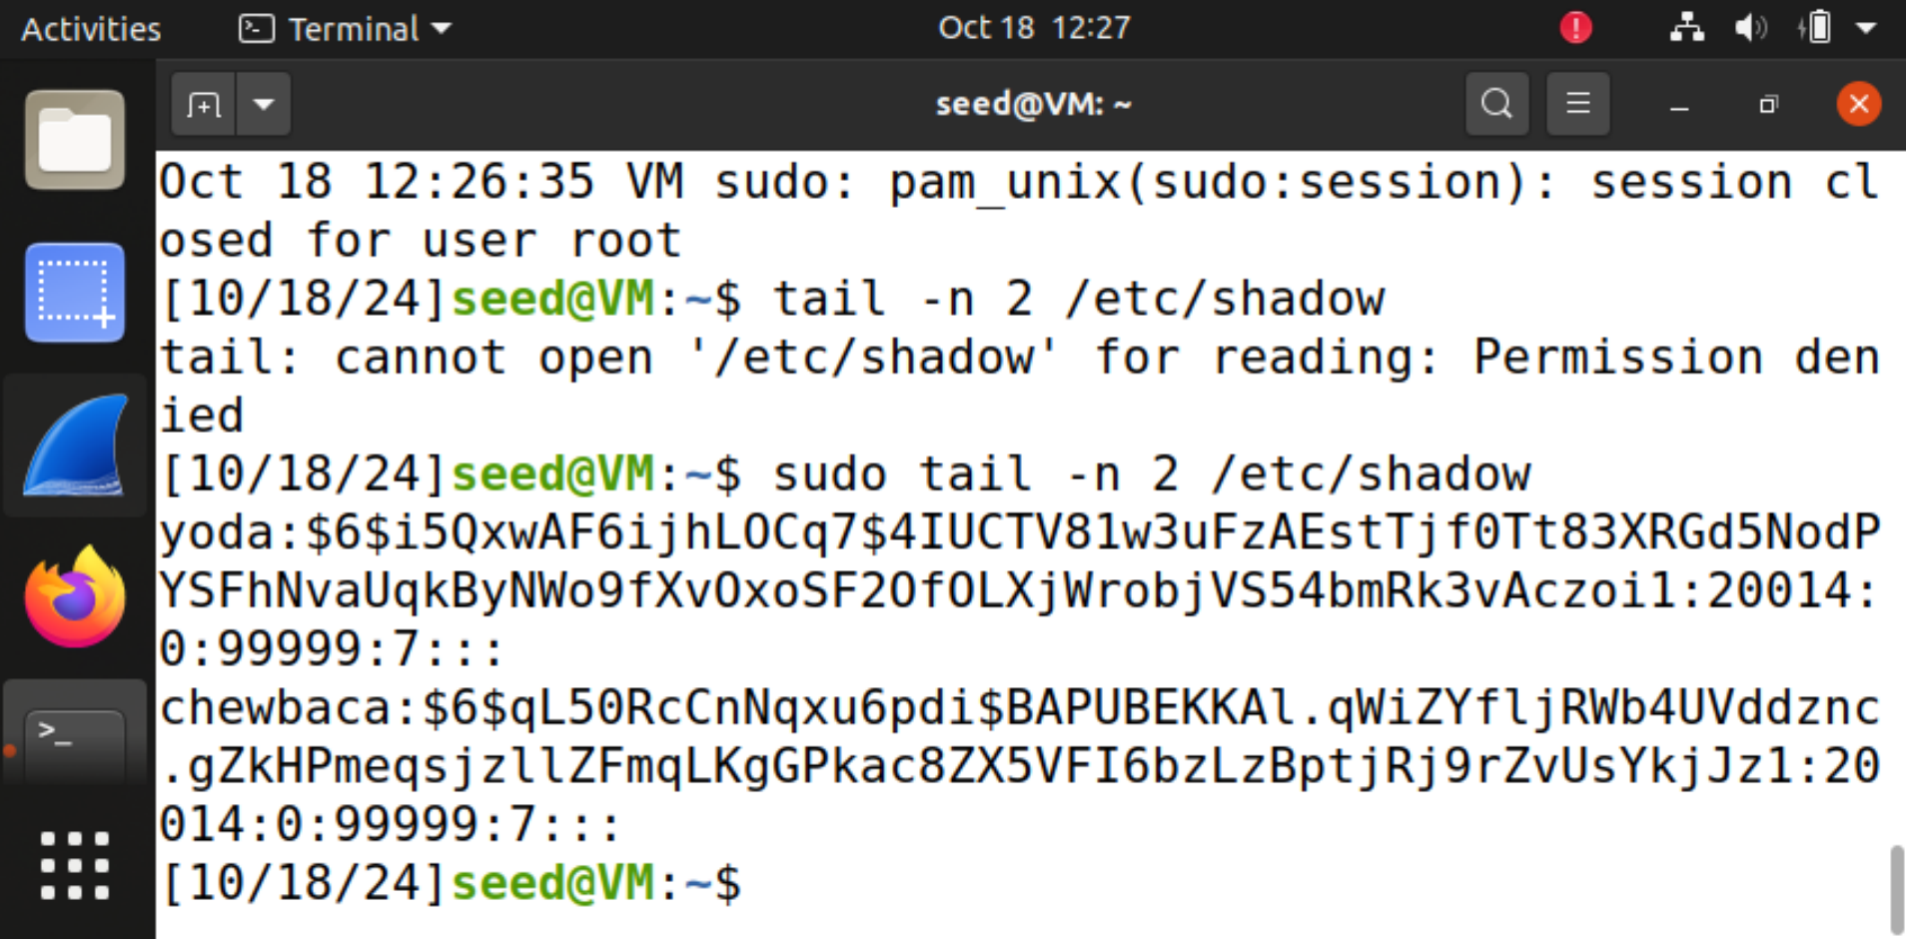

**12. Examine the entries in the auth.log related to account changes by typing:**

**tail /var/log/auth.log**

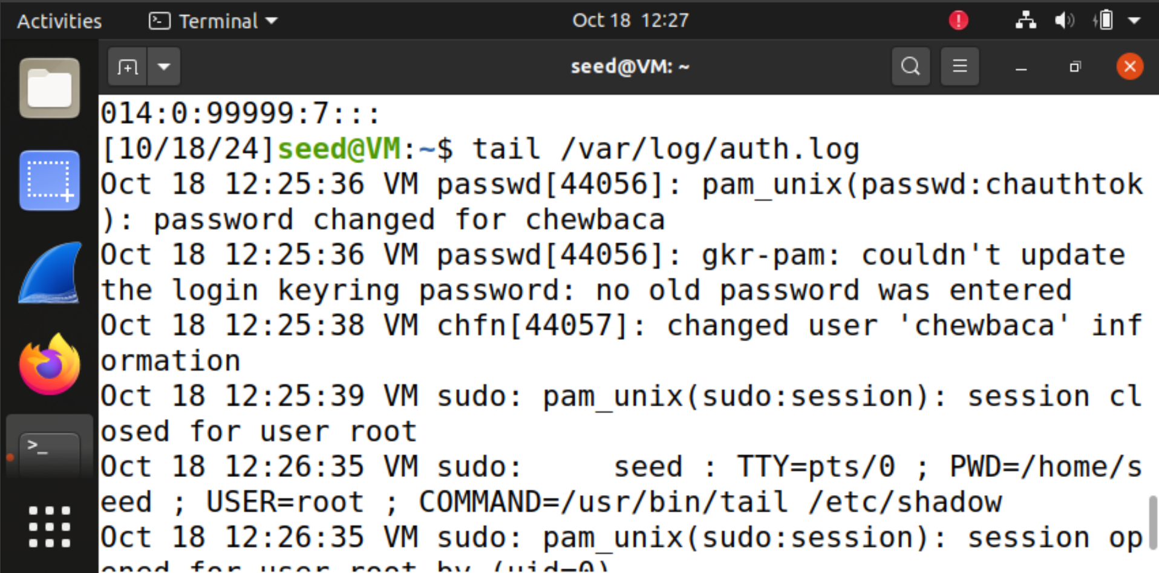

**13. To look for specific information about password changes within auth.log, type:**

**cat /var/log/auth.log | grep changed**

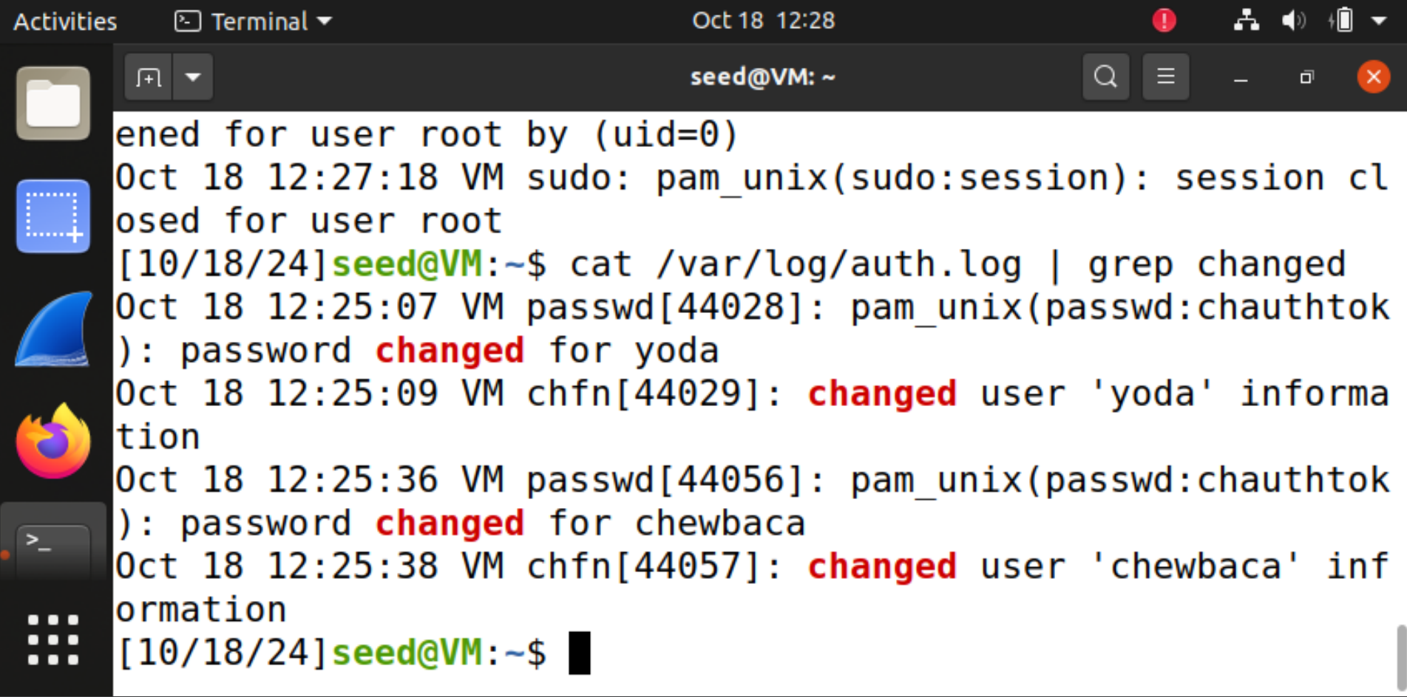

**14. Install john by typing the following command:**

**sudo apt-get install john**

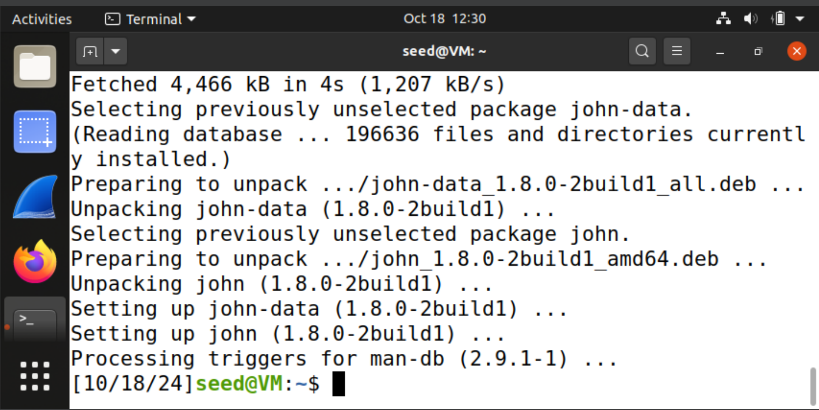

**15. Type the following command to see available switches for the john command:**

**john**

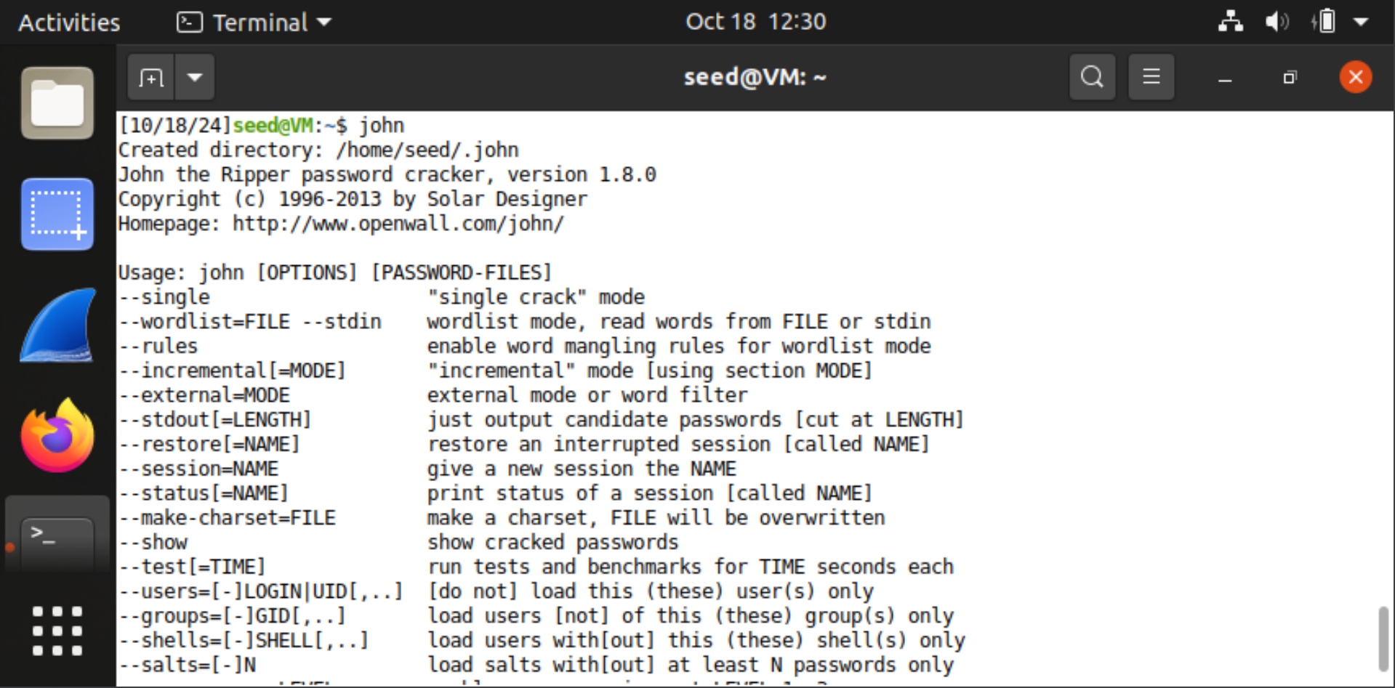

**16. Type the following command to attempt to crack the passwords with john:**

**sudo john /etc/shadow**

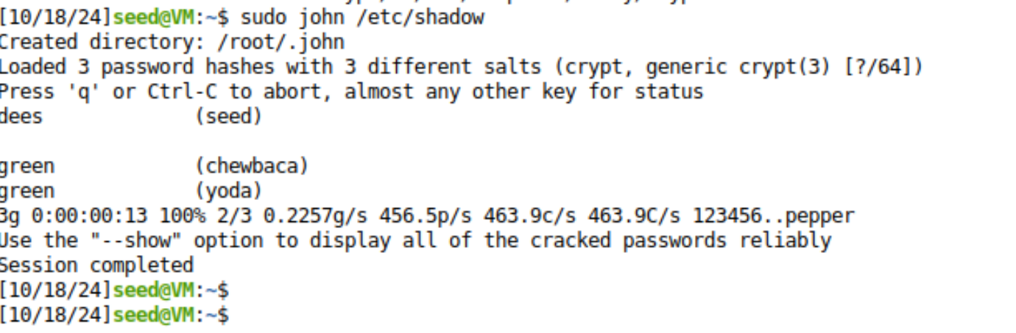

**17. To view the password hashes and corresponding passwords, type the following:**

**sudo cat /root/.john/john.pot**

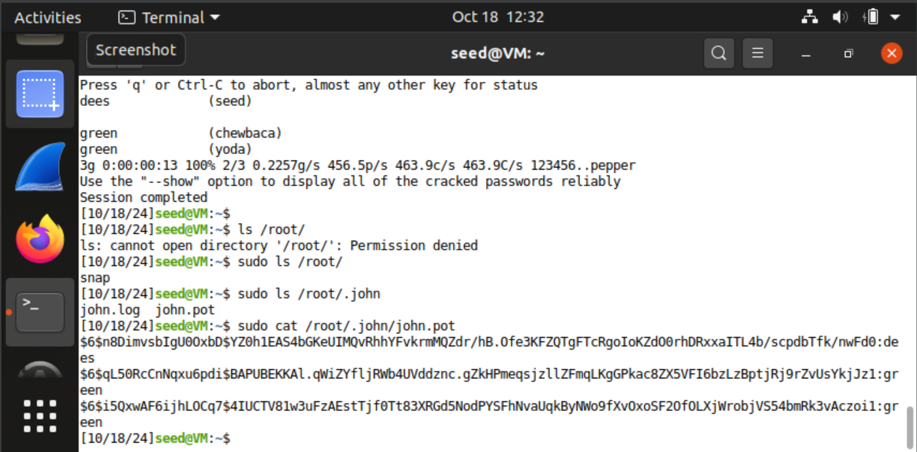

**18. Type the following command to attempt to crack the passwords with john**

**sudo john /etc/shadow**

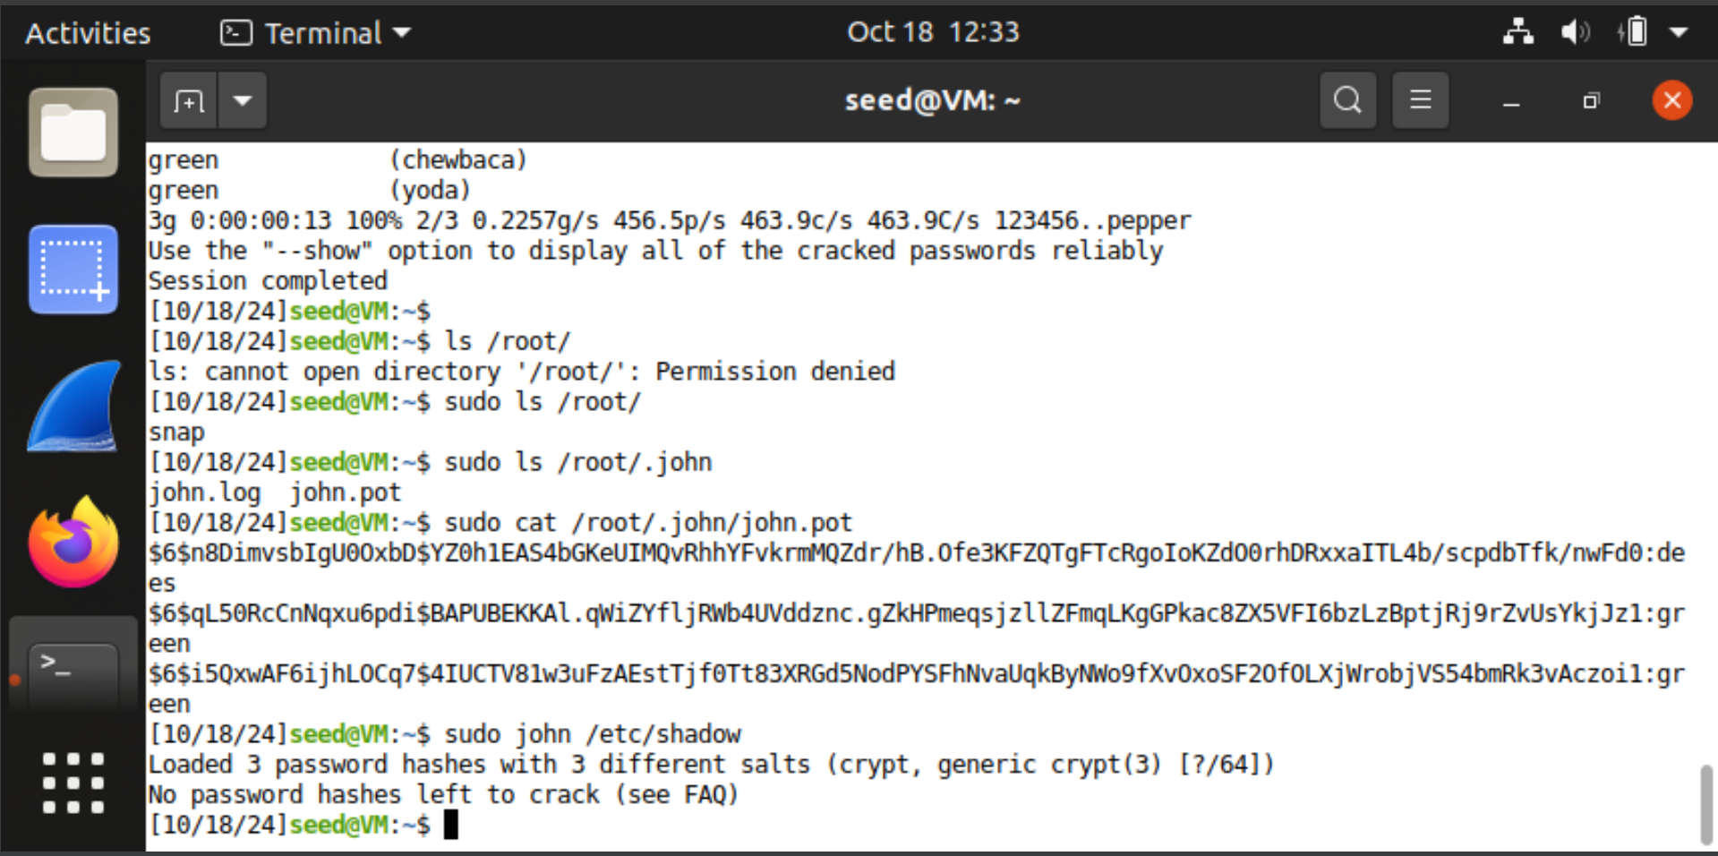

**19. Type the following command to remove the existing john.pot file:**

**sudo rm /root/.john/john.pot**

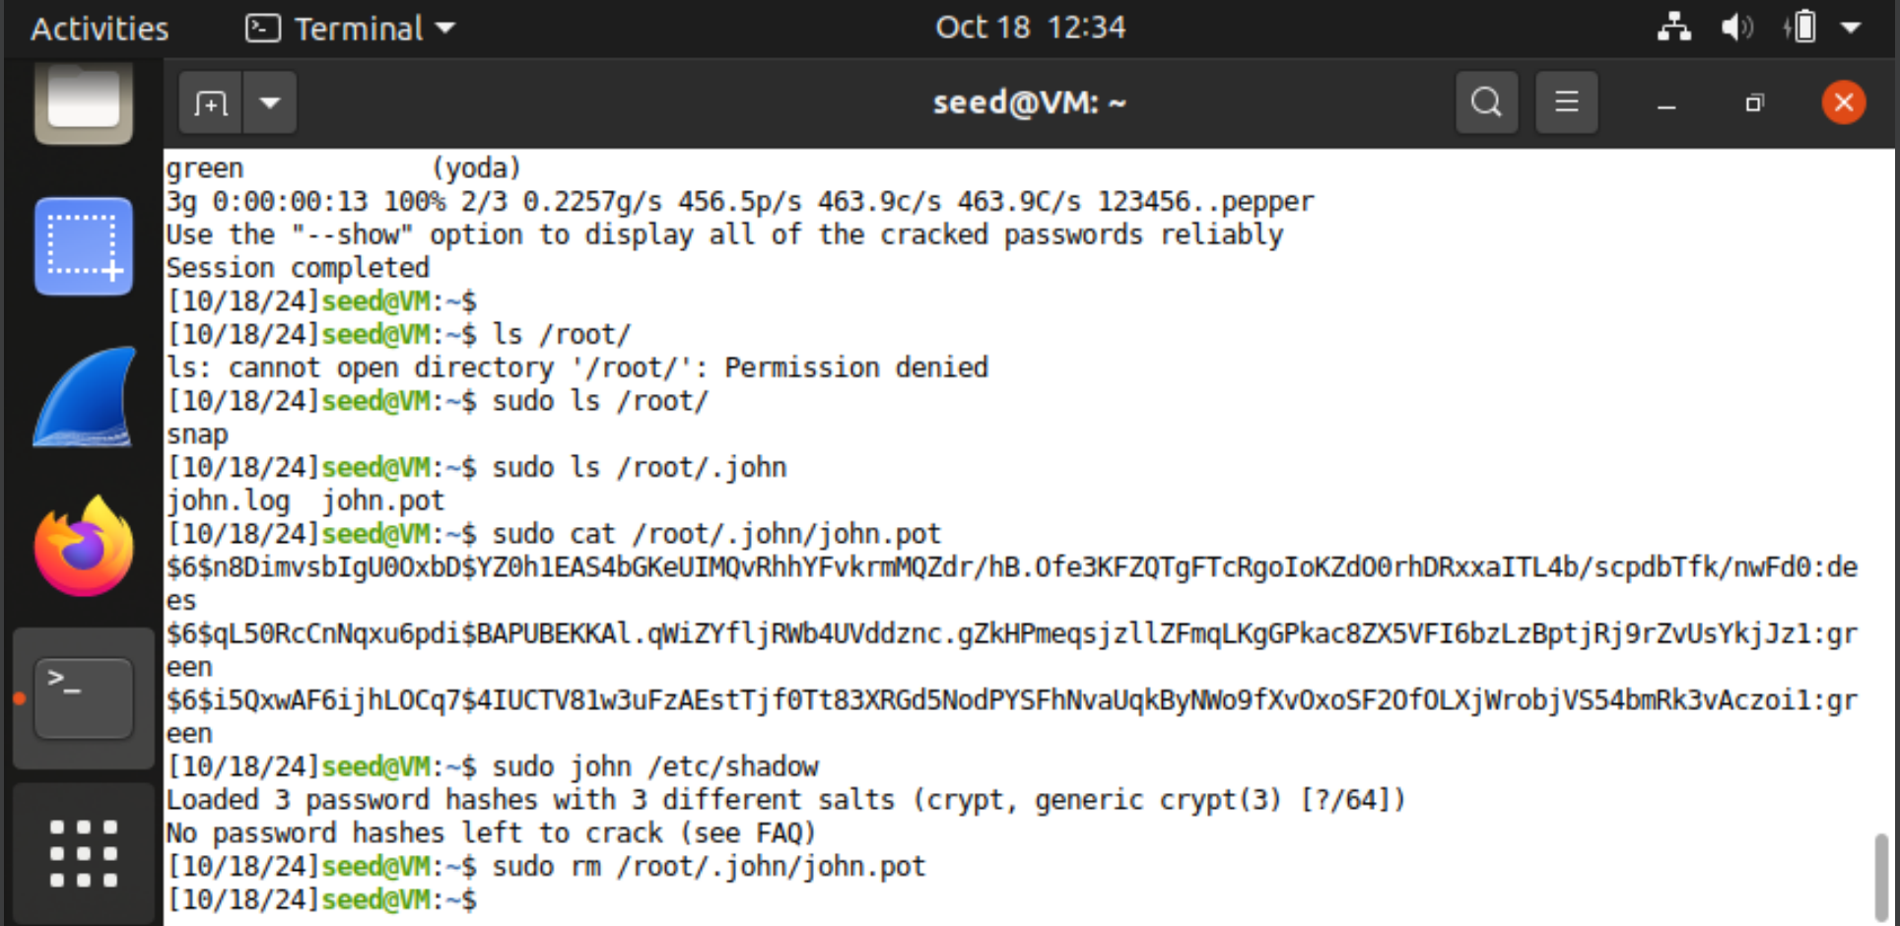

**20. Type the following command to re-crack the passwords with john**

**seed@ubuntu:~$sudo john /etc/shadow**

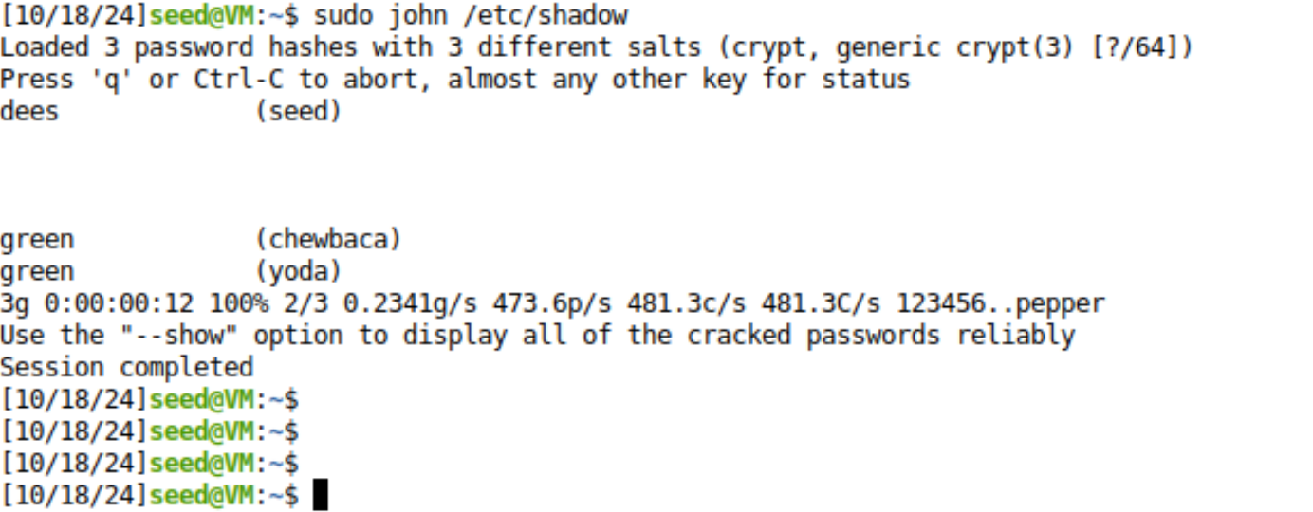

**21. To view the first 20 lines of the file, type the following command in the terminal:**

**head -n 20 /usr/share/john/password.lst**

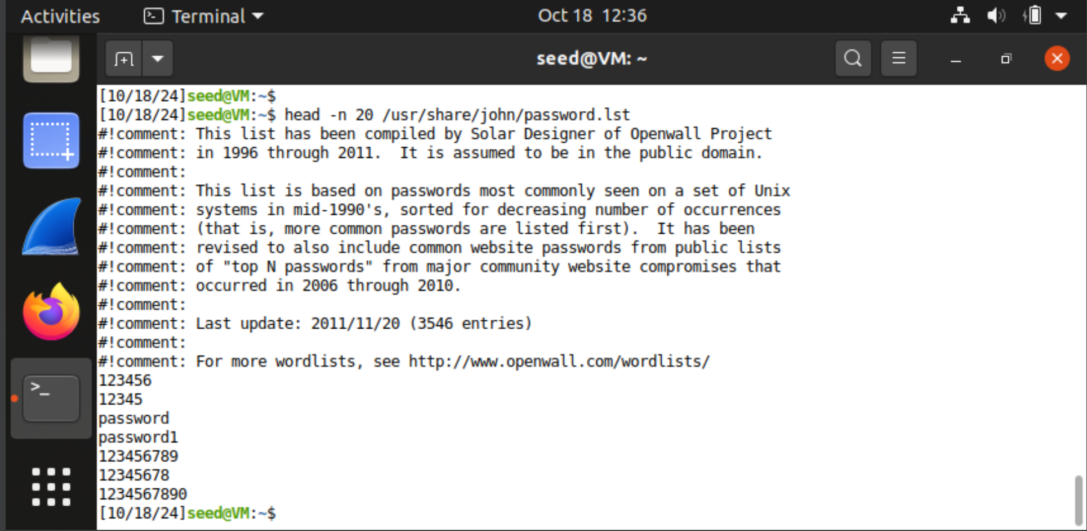

**22. Set chewbacca’s password to computer by typing computer twice after typing:**

**passwd chewbaca**

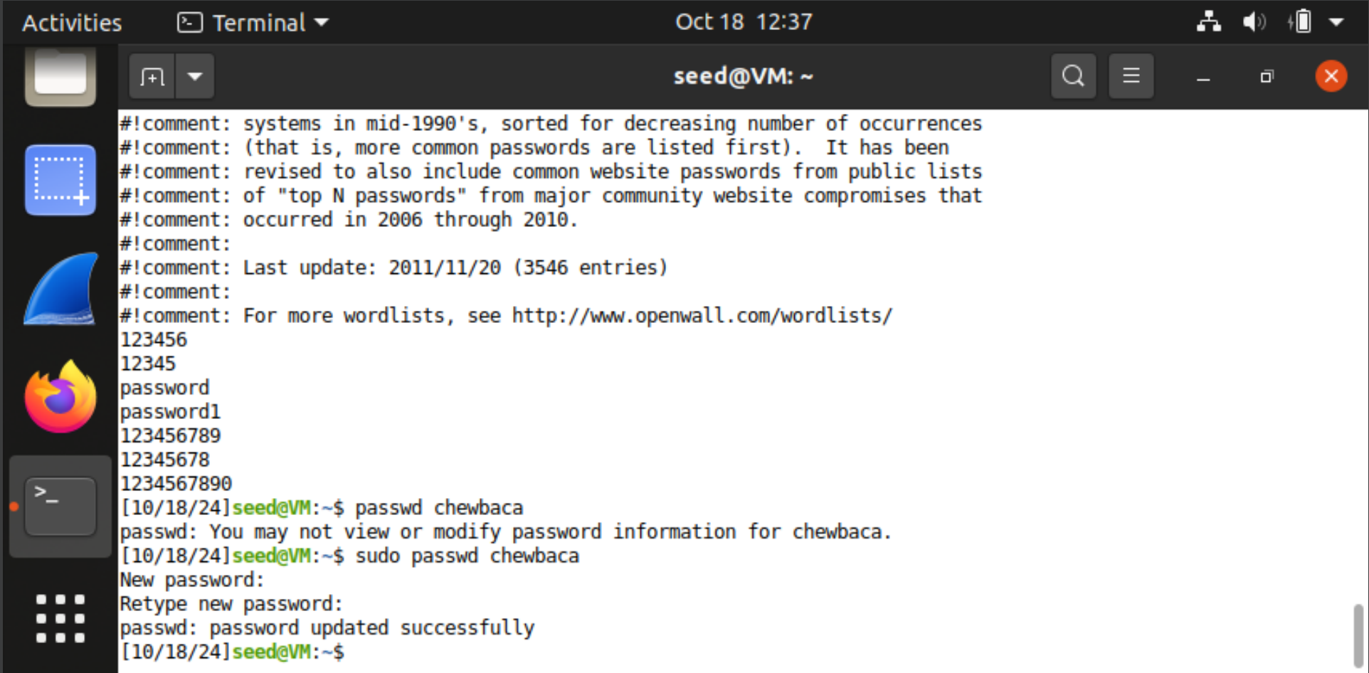

**23. Type the following to run john again and the new password hash will be loaded.**

**john /etc/shadow --wordlist=/usr/share/john/password.lst**

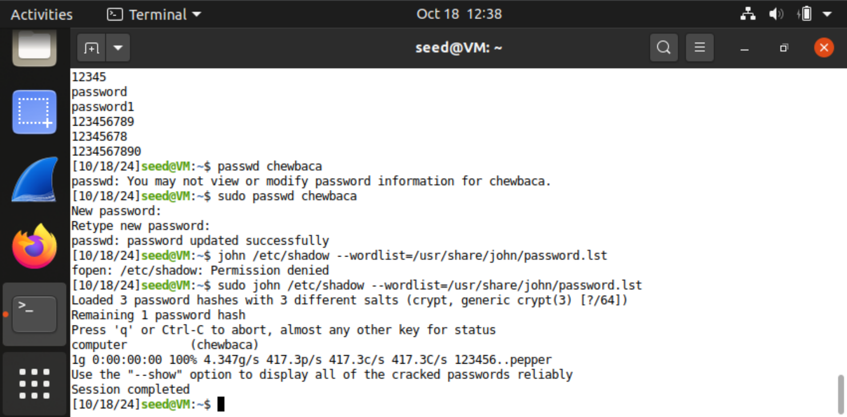

**24. To view the last 20 lines of the file, type the following command in the terminal:**

**tail password.lst**

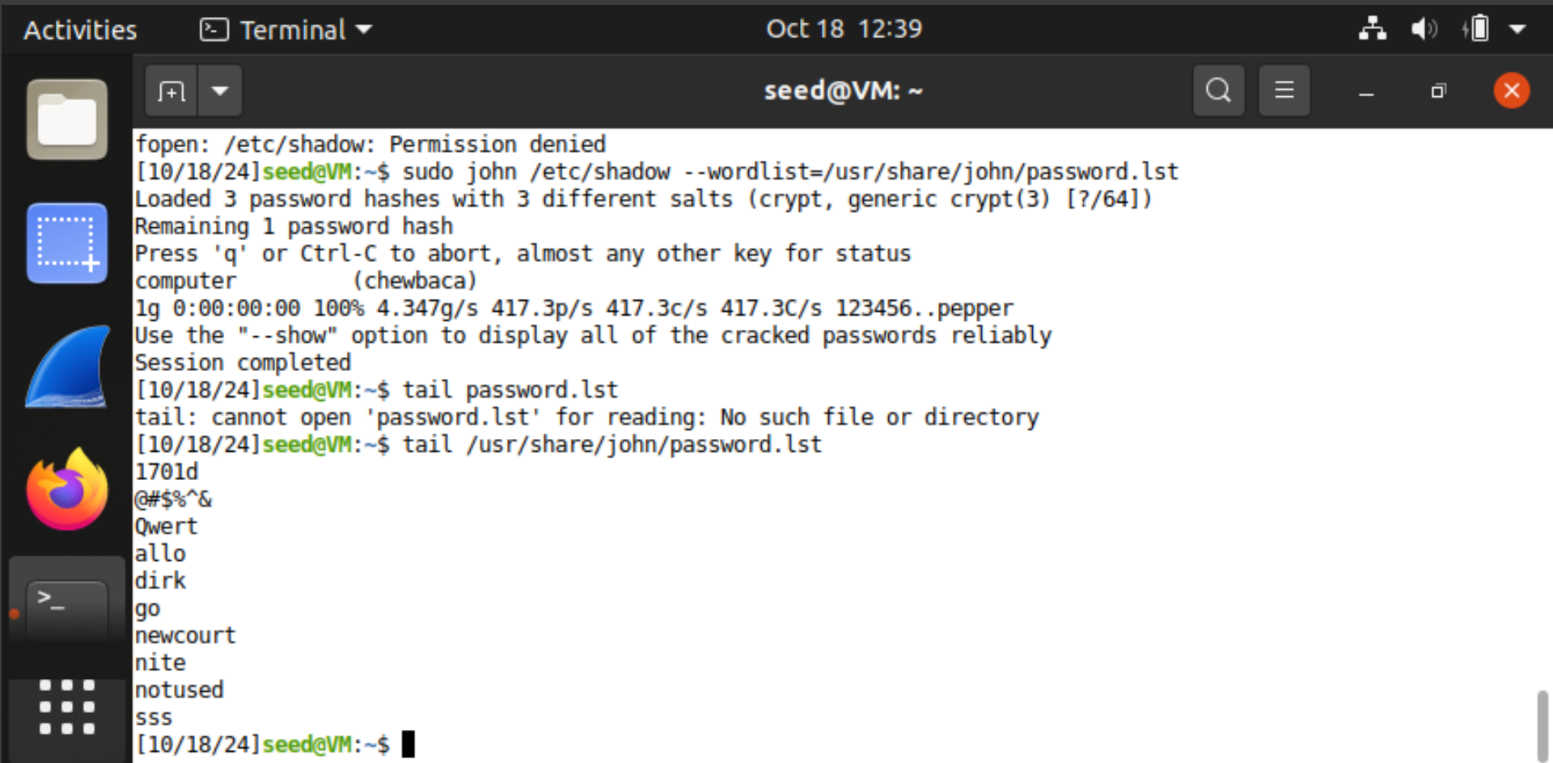

**25. Set chewbaca’s password to 1q2w3e4r by typing twice after typing:**

**passwd chewbaca**

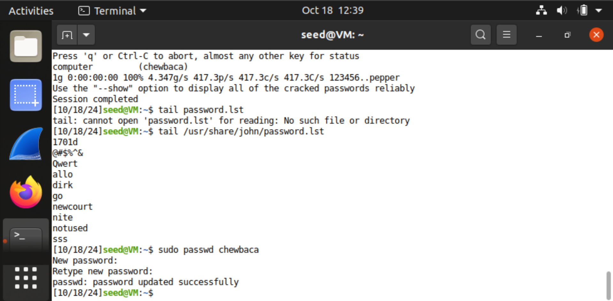

**26. Type the following to run john again and the new password hash will be loaded:**

**john /etc/shadow --wordlist=/usr/share/john/password.lst**

